**Assignment#2**

// Khanmohammadi Amir Hosein, 991646689

// This is a Java class that implements a Bank Account.

// The class has instance variables for account number, name,

// balance, annual interest rate, and date created. It also has

// methods for accessing and setting the values of these variables,

// as well as for withdrawing and depositing money from the account,

// and returning a string representation of the account information.

//2023-02-03

import java.util.Date;

public class BankAccount {

private int accountNumber;

private String name;

protected double balance;

private static double annualInterestRate;

private Date dateCreated;

public BankAccount() {

this.accountNumber = 1000;

this.name = "";

this.balance = 0;

this.dateCreated = new Date();

}

public BankAccount(int accountNumber, String name, double balance) {

this.accountNumber = accountNumber;

this.name = name;

this.balance = balance;

this.dateCreated = new Date();

}

public int getAccountNumber() {

return this.accountNumber;

}

public void setAccountNumber(int accountNumber) {

this.accountNumber = accountNumber;

}

public String getName() {

return this.name;

}

public void setName(String name) {

this.name = name;

}

public double getBalance() {

return this.balance;

}

public void setBalance(double balance) {

this.balance = balance;

}

public double getAnnualInterestRate() {

return annualInterestRate;

}

public static void setAnnualInterestRate(double annualInterestRate) {

BankAccount.annualInterestRate = annualInterestRate;

}

public Date getDateCreated() {

return this.dateCreated;

}

public void withdraw(double amount) {

this.balance -= amount;

}

public void deposit(double amount) {

this.balance += amount;

}

@Override

public String toString() {

return String.format(

"accountNumber: %d\nAccount holder's Name: %s\nAccountBalance: %.2f\nDate Account Created: %s",

this.accountNumber, this.name, this.balance, this.dateCreated);

}

}

// Khanmohammadi Amir Hosein, 991646689

// This is a Java class that extends the BankAccount class

// and creates a CheckingAccount type of bank account with

// an overdraft limit and a unique toString method that includes

// "Account type: Checking".

//2023-02-03

public class CheckingAccount extends BankAccount {

protected int overdraftLimit = 6000;

public CheckingAccount(int accountNumber, String name, double balance) {

super(accountNumber, name, balance);

}

@Override

public String toString() {

return super.toString() + "\nAccount type: Checking\n";

}

}

// Khanmohammadi Amir Hosein, 991646689

// This is a Java class that extends the BankAccount class

// and creates a SavingsAccount type of bank account with methods

// to calculate and return the monthly interest rate and monthly

// interest, and a unique toString method that includes

// "Account type: Savings".

//2023-02-03

public class SavingsAccount extends BankAccount {

private static double annualInterestRate;

public SavingsAccount() {

super();

}

public SavingsAccount(int accountNumber, String name, double balance) {

super(accountNumber, name, balance);

}

public static void setAnnualInterestRate(double annualInterestRate) {

SavingsAccount.annualInterestRate = annualInterestRate;

}

public double getMonthlyInterestRate() {

return balance * (annualInterestRate / 12);

}

public double getMonthlyInterest() {

return getBalance() * getMonthlyInterestRate();

}

@Override

public String toString() {

return super.toString() + "\nAccount type: Savings\n";

}

}

// Khanmohammadi Amir Hosein, 991646689

// This is a Java class that tests the BankAccount and its

// subclasses, CheckingAccount and SavingsAccount, by creating

// objects of these classes, performing actions such as withdrawal

// and deposit, setting annual interest rate, and displaying account

// information and monthly interest amount. The accountInformation

// method is used to display the information of a BankAccount object,

// which is accomplished by calling the toString method.

//2023-02-03

public class TestBankAccount {

public static void main(String[] args) {

// Create checking account

CheckingAccount checking = new CheckingAccount(1001, "John P Smith", 20000);

// Create savings account

SavingsAccount savings = new SavingsAccount(1002, "Janet E Holand", 10000);

// Withdrawal from checking account

checking.withdraw(2500);

// Deposit to savings account

savings.deposit(3000);

// Set annual interest rate for savings account

SavingsAccount.setAnnualInterestRate(0.045);

// Display information for checking account

accountInformation(checking);

// Display information for savings account

accountInformation(savings);

// Display monthly interest amount for savings account

System.out.println("Monthly interest amount of savings account is: " + savings.getMonthlyInterestRate());

}

public static void accountInformation(BankAccount account) {

System.out.println(account);

}

}

**Program output Screen Shot**

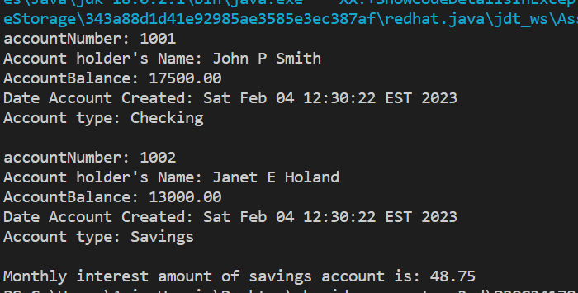

**BankAccount Class UML**

|  |
| --- |
| BankAccount |
| -accountNumber : int  -name : String  #balance : double  -annualInterestRate : double  -dateCreated : Date |
| +BankAccount()  +BankAccount(accountNumber: int, name: String, balance: double)  +getAccountNumber() : int  +setAccountNumber(accountNumber: int) : void  +getName() : String  +setName(name: String) : void  +getBalance() : double  +setBalance(balance: double) : void  +getAnnualInterestRate() : double  +setAnnualInterestRate(annualInterestRate: double) : void  +getDateCreated() : Date  +withdraw(amount: double) : void  +deposit(amount: double) : void  +toString() : String |

**CheckingAccount Class UML**

|  |
| --- |
| CheckingAccount |
| # overdraftLimit : int |
| + CheckingAccount(accountNumber: int, name: String, balance: double)  + toString() : String |

extends

|  |
| --- |
| BankAccount |

**SavingsAccount Class UML**

|  |
| --- |
| SavingsAccount |
| - annualInterestRate : double |
| + SavingsAccount()  + SavingsAccount(accountNumber: int, name: String, balance: double)  + setAnnualInterestRate(annualInterestRate: double) : void  + getMonthlyInterestRate() : double  + getMonthlyInterest() : double  + toString() : String |

extends

|  |
| --- |
| BankAccount |